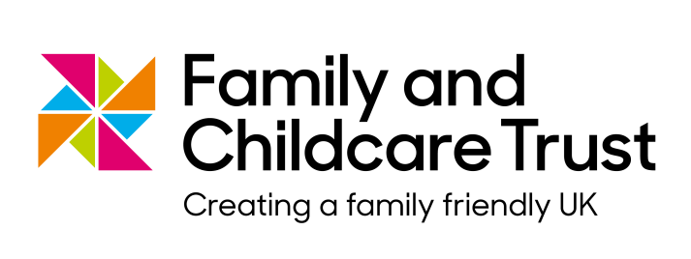

**Recruitment Pack**

Thank you for your interest in working for the Family and Childcare Trust.

This pack contains some information about us, our history and employment benefits to go alongside the job description and person specification.

The Family and Childcare Trust was formed by a merger between the Daycare Trust and the Family and Parenting Institute. This review showcases our charity’s work from when it was formed at the beginning of 2013 through to the end of the financial year 2014/15.

We work to make the UK a better place for families. Our vision is of a society where government, business and communities do all they can to support every family to thrive.

Through our research, campaigning and practical support we are helping to create a more family friendly UK.

We have over 40 years of experience of family life. We use our expertise to advocate for families – campaigning for quality childcare that is affordable and accessible to all parents and promoting employments rights for parents. We:

* Publish annual research on childcare that is recognised as the definitive source of data on childcare in the UK.
* Work directly with parents, on behalf of governments and local authorities, to support them to find information and advice.
* Campaign for affordable, quality childcare through working with government, independent experts, policy makers, and through partnerships and coalitions.
* Carry out research on a range of family issues, such as extended schools and innovation in childcare provision.
* Develop and deliver new approaches to reach families with quality information, such as our ground-breaking peer-to-peer network of Parent Champions.
* Help specific groups, such as families with disabled children, by campaigning for equal access to childcare and by providing useful resources for parents.
* Work with businesses to help them develop family friendly policies for their employees and for their customers.

For more information on the organisation and the work we do please see our website <http://www.familyandchildcaretrust.org/>.

**Employment Benefits**

**Annual Leave**

Annual Leave entitlement is 27 days during each leave year (April to March), plus Bank and Public Holidays (pro rata for part time staff). In addition, the office is closed each year between Christmas and New Year. Entitlement is calculated according to completed months of service in year of starting/leaving employment.

**Sickness**

After successful completion of 6 months probationary period (where applicable) qualifying period sick pay will be at 8 weeks full pay and 8 weeks half pay including SSP. During the probationary period sick pay will be at 1 weeks full pay and 1 weeks half pay including SSP.

**Pension**

We have a group personal pension plan which employees are eligible to join once they have been with the organisation for 3 months. The employee contribution is currently a minimum of 1.5%, and the organisation contribution 8%; membership can be backdated to date of commencement.

**Annual Travel Loan**

We provide an interest free travel loan for employees for the purpose of purchasing an annual season ticket for use to travel from home to work or purchasing a mode of transport.

**Childcare Vouchers**

We run a childcare vouchers scheme which employees are able to sign up to through their salary using salary sacrifice.

**Discount Scheme**

We have an online discount scheme for employees which is operated by Busy Bees. As an employee you will get access to discounts, offers and cash back deals both locally and nationally. You can enjoy savings on the majority of lifestyle costs such as food shopping, household bills, days out, leisure activities, DIY and entertainment.