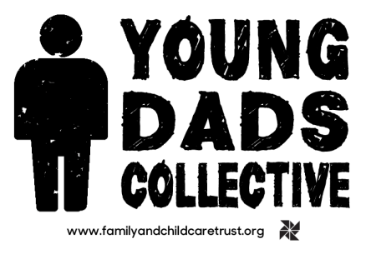
Writing a Good Cover Letter
A cover letter is the most important part of your job application. Many employers will decide to interview or not based on the quality of this letter. That’s why it’s so important to make a good impression. But it can be difficult to know what to write. This letter should tell the employer why they want to hire you and make them want to look into your C.V.
Do some Research
Take some time to find out about the place you are applying to. What do they do and what do they believe in? Take some time to think about how your experience can reflect that.

Writing the Letter

First Paragraph
Use this to say what you are applying for and where you found the advert.

Second paragraph
This is your longest paragraph. Tell them why you are suitable for the job. Briefly describe your past experience. Stick to only relevant information by using the job specification as a guide.

Third paragraph
Let them know you have researched the company here. Tell them what you like about the way they work.

Fourth paragraph
Keep this very brief and tell them again how much you would like the role and why you are the right person for it. You can also tell them that you look forward to meeting or hearing from them.
Finally finish your letter with ‘Yours Sincerely’ and your name.

Presentation is everything
Set your cover letter out in a simple letter format and make sure it is addressed to the write person. You will usually be able to find that information on the original job application. Make sure you get someone to spell check and proof read any application you send!

If you have any questions about the application please email: Ruben@familyandchildcaretrust.org

