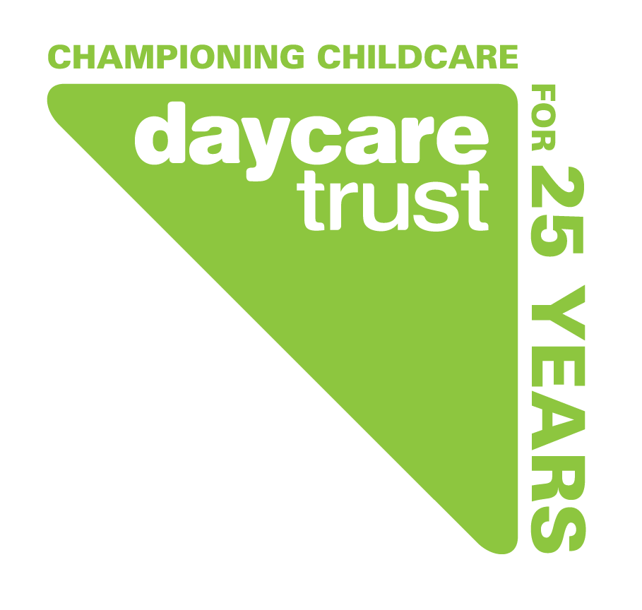
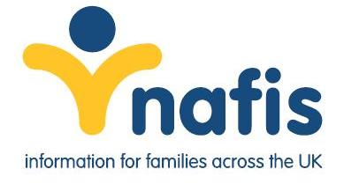

NAFIS Annual Conference 2012

Feedback form

What prompted you to attend the conference?
Speaker line up Cost Both
130
4
1

Other:
- Chance to network
- Links with FIS/ Network
- Recent presentation of Anand to the south west group of managers
- Not been to a conference for some time
- Information on new initiatives
- Networking opportunities
- Networking opportunities and to see how Daycare Trust would run this
- Anand attending regional meeting
- Last minute availability of a place
- Networking with other FIS’s
- To catch up with FIS and what is going on at a local level
- Call centre workshop
- The future of FIS’s
- To keep up to date with new developments and future of FIS
- networking opportunity

Where did you hear about the conference?
6
Daycare Trust e-bulletin

Daycare Trust website
1

Mailing
3

Insert
0

Other:
- NAFIS list
- Regional FIS managers meeting- Anthony came as a guest
- Manager
- Previous Daycare Trust conference

Did the conference meet your expectations?
27
Yes

No
1

Comments
- It is good NAFIS is back where it should be supporting FIS
- Very well delivered
- Better than last year (NAFIS alone)
- Only the parent’s champions had a real impact
- Brilliant!! And very interesting!
- Sound quality poor at times
- I would have liked to have heard more about the digital advisory service
- It was good to hear from colleagues in similar positions regarding the shaky future of FIS’s nationally

Please assess the following:
 | Excellent | Good | Average | Unsatisfactory
Overall Conference | 16 | 8 | 3 | 0
Content | 12 | 12 | 3 | 0 0
Speakers | 11 | 13 | 3 | 0
Q & A | 8 | 11 | 7 | 1 2
Venue facilities | 15 | 8 | 2 | 1 1
Catering | 10 | 12 | 5 | 0
Event organisation | 13 | 12 | 1 | 0
Networking opportunities | 14 | 13 | 1 | 0

Comments
- Ladies from Liverpool- inspiring!
- Good venue, easy to access from railway station
- Lot of external noise could be heard in room- from outside.
- Room to noisy and crowded for round table discussions
- Best NAFIS conference that I have attended so far
- Feedback from microphones very annoying and off putting
- Cramped conference room
- Speaker volume/ feedback really awful
- Once again I felt let down by the lack of acknowledgement for FIS’s from the panels responses during the Q&A with regards to safeguarding section 12 and staff working tirelessly to ensure that it is delivered
- The workshops were excellent because they focused on practical, relevant issues facing FIS
- In hindsight it probably would have been more beneficial to have let Colin have questions for DfE in advance so he would have had less to take back and more answers on the day

What was the highlight of the Conference for you?
- Guest speakers
- Hearing about the parent champions
- Performance workshops
- Parent champions
- Parent champions and afternoon workshops
- Parent champions
- We’re not alone in our circumstances!
- The workshops were good
- Having the opportunity to network with colleagues in other LAs and the workshop keeping FIS intact in a call centre
- Was great to meet up with so many other managers again as the opportunities are so rare these days. I have already dealt with a couple of issues as a result of contacts made last week

Please assess the following:

Speakers | Excellent | Good | Average | Unsatisfactory
Anand Shukla, Daycare Trust | 10 | 13 | 2 | 0
Katherine Rake, Family & Parenting Institute | 12 | 15 | 0 | 0
Kerstin Neason, Barnardo’s | 9 | 14 | 1 | 0
Colin Stiles, Department of Education | 4 | 7 | 14 | 2
Parent Champions Launch | 15 | 7 | 2 | 0
Workshops
Gavin Barber, Oxfordshire FIS | 12 | 1 | 0 | 0
Roz Hampson, Daycare Trust | 5 | 5 | 1 | 0
Esther Burridge, Daycare Trust | 4 | 3 | 1 | 0
Niall MacVicar, York FIS | 10 | 8 | 1 | 0
Anita Abram, Suffolk FIS | 3 | 1 | 1 | 0

Are there any comments you would like to make regarding the speakers?
- All very informative, providing useful incite
- DFE rather disappointing with content
- Parent champion launch disappointing- didn’t really say how this was going to be taken forward, just what had been done already. However, the ladies were excellent telling us about their experiences
- DFE were very poor
- Pre warning that Colin Stiles was going to do Q&A session to consider questions
- Parent’s champion speakers had more impact than the rest of the speakers combined
- Performance management- very useful. Like the idea of national framework
- All brilliant
- Confident and made sense!
- The two other speakers with Gavin (sorry can’t remember their names) were very helpful and informative
- You should have asked open family services to speak as this is a national way forward for FIS’s
- Kerstin Neason was an excellent speaker and the parent champions who got up and told their story were truly inspiring

Do you think that there was anything else we should have included in the day?
- No health and safety procedures
- Time to question NAFIS on way forward
- I originally booked on the conference because there was a families first award clinic advertised but this did not happen in the end which was a shame

What, if any, improvements do you feel we could make for future events?
- Market area needs more variety- same stands are there year after year
- More presentations from people on the ground
- Loved the FIS led workshops more of this please
- Main room too crowded –bigger room to move about
- Cheaper- so that more authorities attend
- Would be interested in learning more about the provision of information for parents of disabled children

What two things will you take away from attending the Conference?

- Information
- Ideas and useful tools
- Sharing good practice
- Everyone has some goals and obstacles
- Ideas to bring to FIS
- Parent Champions
- Ideas for parent champions
- Performance management
- Networking- follow up contacts
- Most FIS’s seem to be worried about the future
- We continue to care about what we do and the families we serve
- Parent champions
- Networking opportunities
- Being innovative around measuring outcomes for families
- Interested in national guidance on performance management
- The importance of measuring performance and impact
- Development of outcomes/ supporting professionals
- Parent’s champions
- Networking
- Lots of ideas for new contacts/information streams/ developing partner relationships
- Performance management ideas
- Parent champions
- Tips about call centre merges
- Better understanding of role
- Ideas about working with the customer service centre
- Parent champions- inspirational stories
- Data! Data! Data! – measuring outcomes
- Performance workshops and pre lunch discussions
- Hope! – as we move into a contact centre
- That the government has lots of little pots of money that are going on small initiatives and it could all be joined up better- frustration!!!
- The importance of maintaining good links with NAFIS/Daycare Trust and colleagues in other FIS’s
- Improving strategies for marketing the FIS to professionals
- Trying to get our FIS firmly placed as part of the early intervention agenda
- Very inspiring to be amongst other FIS colleagues
- Good practice in negotiating with local authority on contact centre issues
- How do demonstrate outcomes/ effectiveness
- A strong feeling of support through Daycare Trust and their ability to reach those in Government
- Excellent contacts and advice gained through networking

Any further comments
- Would have been great to be able to fit more workshops into the day
- Little point in Colin Stiles – Said a lot without saying anything useful!
- It’s a shame there wasn’t more FIS’s present
- It would have been more useful if the DfE had brought more information to share rather than just facilitating discussion on our tables and not really having any input back

How many conferences do you attend in the year?

1 2 3 more than 3
150
8
1
1

What subjects/areas would you like to see NAFIS cover in future conferences?
15
Info for parents of disabled children
1
Families First Quality Award
10
Brokerage
13
Outreach

Taking on other work outside s.12
16

Other:

And finally, please let us know of any training needs that you may have what subjects would you find it useful for our training courses to cover?

- Training for taking on other work outside s.12. possibly good practice delivery from FIS’s who already do this
- Raising profile of FIS with LA executive
- Regional training opportunities for all staff and networking to exchange good/best practice
- General benefits/ credits training locally for information and outreach team
- Regional training on personalised budgets

